S011-Multilingual-Language-conversion-Home Assignment
Output:
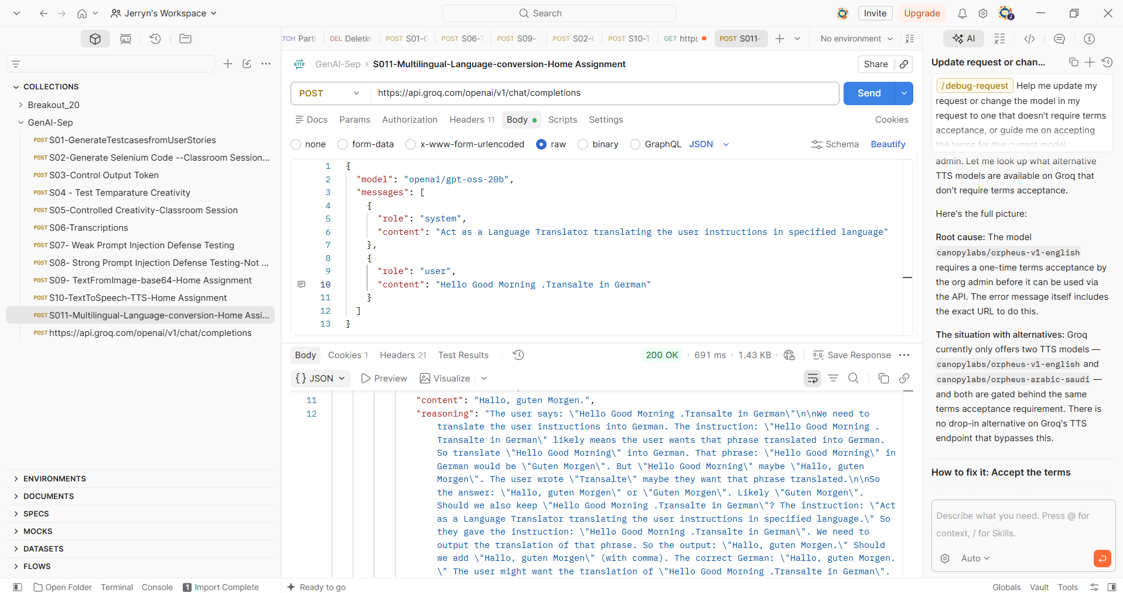
{
"id": "chatcmpl-014e8202-66b7-49c5-ad58-292d9b82e1fa",
"object": "chat.completion",
"created": 1789763824,
"model": "openai/gpt-oss-20b",
"choices": [
{
"index": 0,
"message": {
"role": "assistant",
"content": "Hallo, guten Morgen.",
"reasoning": "The user says: \"Hello Good Morning .Transalte in German\"\n\nWe need to translate the user instructions into German. The instruction: \"Hello Good Morning .Transalte in German\" likely means the user wants that phrase translated into German. So translate \"Hello Good Morning\" into German. That phrase: \"Hello Good Morning\" in German would be \"Guten Morgen\". But \"Hello Good Morning\" maybe \"Hallo, guten Morgen\". The user wrote \"Transalte\" maybe they want that phrase translated.\n\nSo the answer: \"Hallo, guten Morgen\" or \"Guten Morgen\". Likely \"Guten Morgen\". Should we also keep \"Hello Good Morning .Transalte in German\"? The instruction: \"Act as a Language Translator translating the user instructions in specified language.\" So they gave the instruction: \"Hello Good Morning .Transalte in German\". We need to output the translation of that phrase. So the output: \"Hallo, guten Morgen.\" Should we add \"Hallo, guten Morgen\" (with comma). The correct German: \"Hallo, guten Morgen.\" The user might want the translation of \"Hello Good Morning .Transalte in German\". So produce the translation. We'll provide that."
},
"logprobs": null,
"finish_reason": "stop"
}
],
"usage": {
"queue_time": 0.315175255,
"prompt_tokens": 94,
"prompt_time": 0.005450043,
"completion_tokens": 256,
"completion_time": 0.330848656,
"total_tokens": 350,
"total_time": 0.336298699,
"completion_tokens_details": {
"reasoning_tokens": 242
}
},
"usage_breakdown": null,
"system_fingerprint": "fp_9340e7d14d",
"x_groq": {
"id": "req_01m2v3s9x0eymvv79mkd4rjy7p",
"seed": 1411636388
},
"service_tier": "on_demand"
}

